ICP Forests
Meeting of the heads of the laboratories

19th and 20th September 2013
Hotel Kolovare, Zadar, Croatia

Event information

Registration

Please return the registration form by 1st August 2013 to:
Tamara Jakovljević
Croatian Forest Research Institute
Cvjetno naselje 41
10 450 Jastrebarsko
Croatia
Phone: +385-1 6273 025
Mobile: +385-98 339 860
Fax: +385-1 6273 035
E-mail: tamaraj@sumins.hr

Registration fees & costs

Registration fee:

Meeting: 150 €

Excursion Krka National Park, 20th Sep.: 40 €
(includes transport, entrance & dinner)

The meeting and the excursion to National Park have to be paid upon the arrival at the registration desk in Euros.

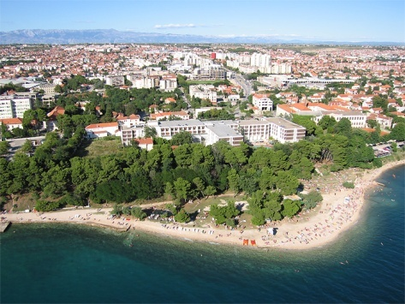
Venue

The meeting of the heads of the laboratories will take place at:

HOTEL KOLOVARE
Bože Peričića 14 | 23 000 Zadar | Croatia
http://www.hotel-kolovare.com/en/about-us/
Tel. +385 23 211 017, 203 200
Fax. +385 23 213 079, 203 300

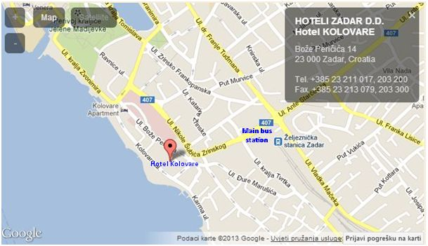

Accommodation

The official hotel of the meeting is Hotel Kolovare which is located near the historical sights of the ancient city of Zadar, in a peaceful and picturesque part of the city.
Participants are requested to make their accommodation arrangements and payment by themselves.
If you reserve the room in Hotel Kolovare on info@hotel-kolovare.com with reference to “ICP Forests Meeting of the heads of the laboratories“ then the rooms are available with a discount.

Single room – 85 €/night
Double room/shared use – 60 € per person
Breakfast included

If you would prefer some other accommodation, please relate to this map of the peninsula:
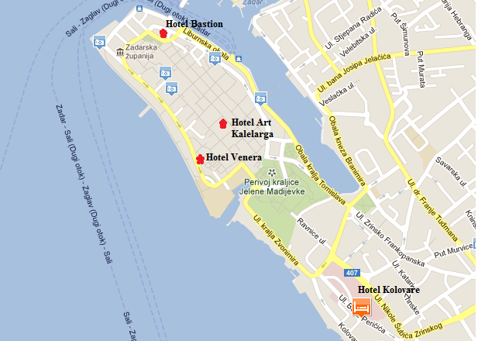

It contains hotels in the centre of the town, in the walking distance from hotel Kolovare (meeting venue).

Our suggestion is the accommodation on the peninsula:

Hotel Venera **
http://www.hotel-venera-zd.hr/english.html
Featuring free Wi-Fi, this friendly hotel enjoys an excellent location in the centre of the historic old town of Zadar. Hotel Venera offers comfortable rooms in a quiet alley, away from the noise of the city. It is surrounded by many restaurants, bars and cafés. Many attractions such as the Sea Organ, as well as museums and the beautiful waterfront of Zadar, are just a few steps away from Hotel Venera.
Art hotel Kalelarga****
http://www.arthotel-kalelarga.com/en

Hotel features 10 thematically designed guest rooms, which are characterized by functionality, harmony, fine materials, shapes and colors. The incorporation of stone pavement in design creates a sense of expansion of the Kalelarga Street into and through the interior space of a building.

Hotel Bastion****
http://www.hotel-bastion.hr/

It is located in the historic core, built on the remains of the medieval fortress “Kastela” from the thirteenth century; an invaluable monument of medieval fortification in Zadar.
Hotel Bastion offers 28 luxury equipped rooms, an assortment of gastronomic delicacies, wellness canter and a videoconference room which turns business into pleasure.
How to reach Zadar?

By airplane
http://www.zadar-airport.hr/en
The Zadar airport - Zemunik (ZAD) is very well connected to bigger towns of Croatia and Europe with low-cost flights. It is situated only 20 minutes by bus from Zadar. There's a bus from the airport to the city and it takes you to the main bus station which is in the walking distance from the hotel Kolovare http://www.zadar-airport.hr/en/how-to-reach-us
You can also use a taxi from the airport to the hotel. In both cases make sure to have kuna (kn) with you. Taxi costs ca.150 kn (ca. 20 €) and the bus costs 25 kn (ca. 4 €).
You can also fly to Split airport http://www.split-airport.hr/index.php?lang=en
and reach Zadar by bus which drives every hour http://www.ak-split.hr/EN/index.html

By bus
http://www.buscroatia.com/bus-station-zadar/

Zadar is the centre of north Dalmatia and very well connected with other Croatian and bigger European towns.

By car
You can come to Zadar from several directions and the highway A1, route Zagreb - Split, is the quickest and best of all. The best exit from the highway is at the knot Zadar east or Zadar west.

By ferry
http://www.directferries.co.uk/zadar_ferry.htm

Zadar is connected to Italy by ferry from Cesenatico, Pesaro & Ancona with services operated by Emilia Romagna Lines & Jadrolinija.
Ferry crossings are scheduled to operate up to 9 times weekly with durations from 4 hours.

Visa requirements, etc.

If perhaps you need an entry visa for Croatia, please consult the website of the Ministry of Foreign Affairs of Croatia. There you will find information for your country. http://www.mfa.hr/MVP.asp?pcpid=1615
If the visa is required for an entry to Croatia, please send the email to tamaraj@sumins.hr

And last but not least………..

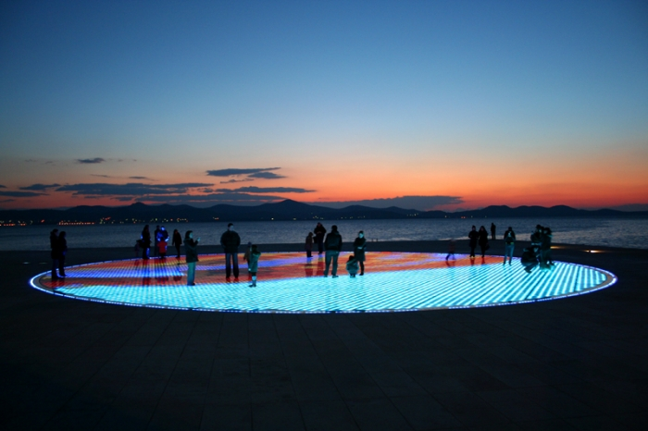

End your conference day at a concert from unique in the world the Sea Organ and enjoy an exceptionally impressive game of light by the Greeting to the Sun
WELCOME TO the meeting of the
heads of the laboratories in ZADAR!

We are looking forward to seeing you in Croatia this year

Croatian Forest Research Institute

