Material test | Comparison of two wet-only samplers: ANDERSEN and EIGENBRODT UNS 130 | deposition samples

Problem / question: The old wet-only sampler (type ANDERSEN, right hand side of the picture below), used in the French level II network between 1993 and 2001 on 8 plots and in Luxemburg on one plot, had no more chance to be modernised, since the manufacturer had changed several times and this wet-only was electronically speaking no more up-to-date. We have therefore switched to a new generation of wet-onlys (type EIGENBRODT UNS 130, left hand side of the picture below) but had to be sure that there will not be a rupture in the results, due to the use of the new wet-only.

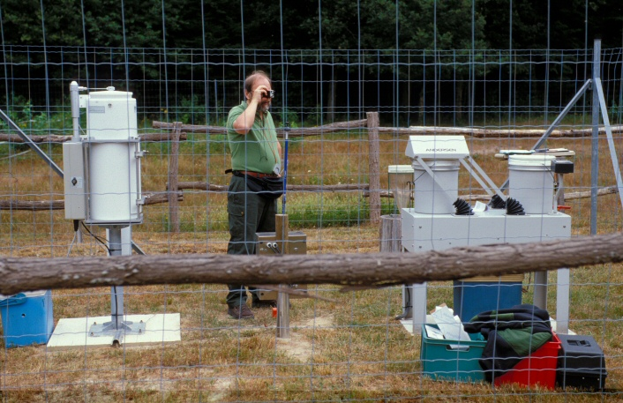

Description of the test:

Both type of sampers were use in parallel for one year at the Fontainebleau site of the network and were sampled and analysed. Sampling was done weekly and analysis was done on a precipitation weighted mean sample of 4 weeks. After one year we had 12 pairs of results (for one period we had a contaminated sample in one wet-only sampler). The samples coming from these collectors are only used for analysis and never for precipitation amount measurements, which are done with an independent manual standard precipitation gauge produced under licence of the national meteorological organisation Météo France.

- results:

As shown in the graphs below, the comparison of the samplers show for sampled volume, Ca, Cl, S-SO₄, Na and alcalinity very good agreement (R²> 0.9) and for N-NH₄, K, Mg and pH good agreement (R² between 0.8 and 0.89) between the old and new sampler. Only the time, during which the samplers were open (R²=0.59) and the N-NO₃ concentrations showed bad agreement.

- consequences:

We consider therefore generally that both samplers give for most parameters comparable results, except for nitrate and the opening time. For the latter, the opening time does not seem to harm the concentrations measured for all, but one parameter (N-NO₃).

literature:

none

executive laboratory:

Institut: Office National des Forêts, Research department, RENECOFOR
Name : Erwin Ulrich, Marc Lanier
Street: Boulevard de Constance
City: F-77300 Fontainebleau
Country: France
e-mail : erwin.ulrich@onf.fr

- tables and graphs, appendix:

